**Task 1 : Get Familiar with SQL Statements**

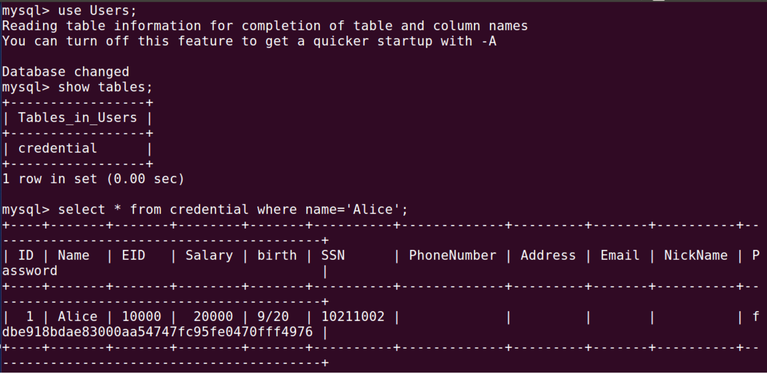

**Observation:**

* I log into MySQL using the following command
  + mysql -u root -pseedubuntu
* Use the database Users and show the tables listed under the database using commands
  + use Users;
  + show tables;
* In order to retrieve all profile information of Alice, use the command,
  + select * from credential where name=’Alice’;

**Task 2: SQL Injection Attack on SELECT Statement**

**Task 2.1:** SQL Injection Attack from webpage

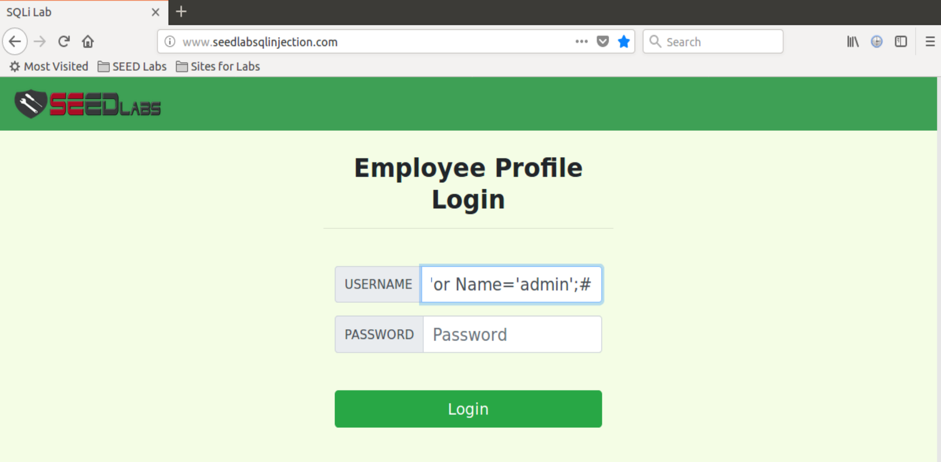

**Observation:** In this task we are given a vulnerable website to exploit SQL Injection attacks by logging in as admin. Given that we know that there exists an account of the administrator called admin, we inject our code as shown above to login without knowing id and password of admin.

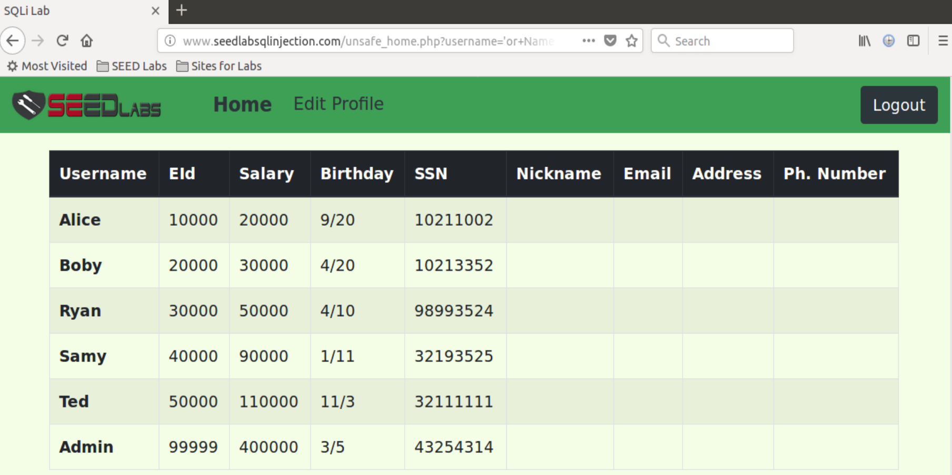

**Observation:** The above screenshot shows that the attack is successful and we logged in as admin without knowing the ID or password of the admin user.

**Explanation:**

* The employee ID and the password fields are input to the where clause. So, what we fill in these fields go into the query.
* To exploit the SQL Injection attack, we inject the following code: ‘ or Name=’admin’;#
* The single quote closes the argument for the input id, the OR statement we insert after that allows us to login as admin. The # is inserted at the end to comment out everything else that follows so that the password input is skipped.

**Task 2.2**: SQL Injection Attack from command line

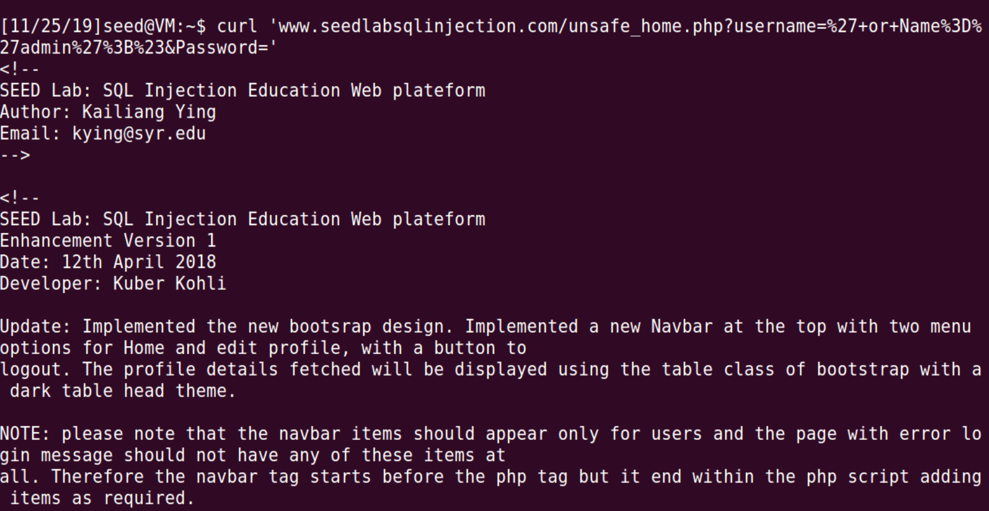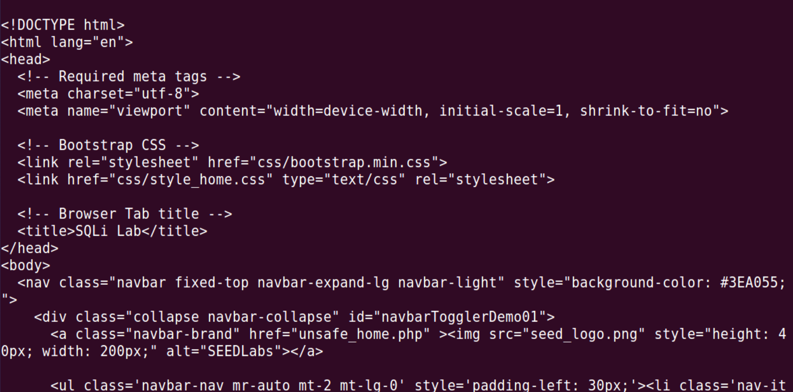

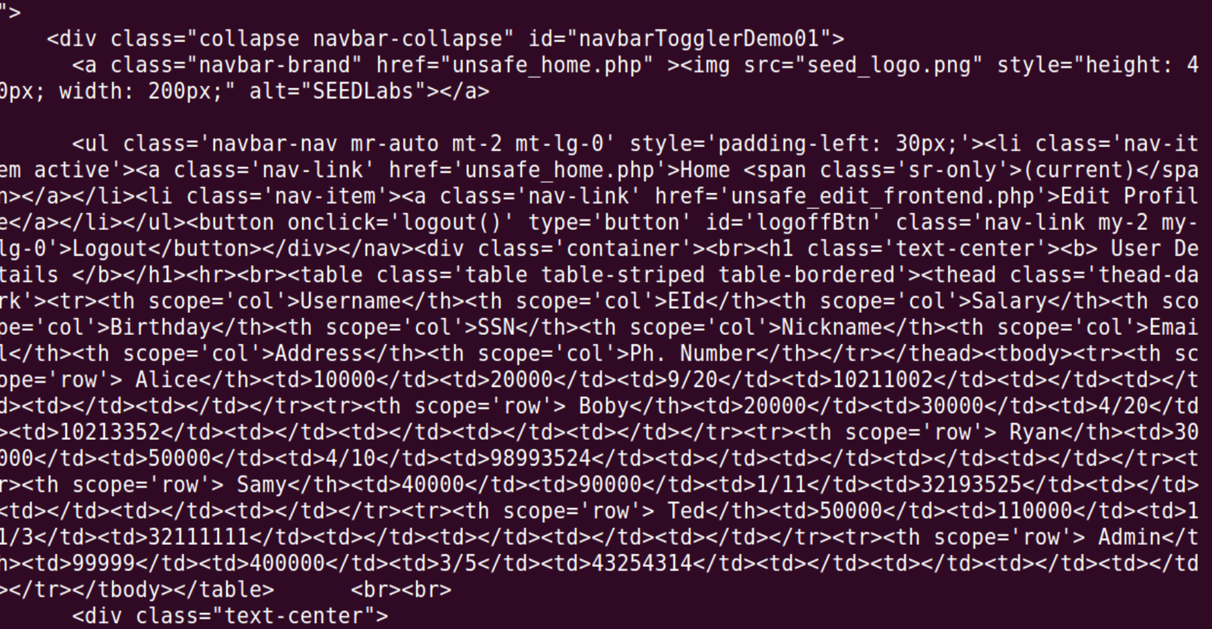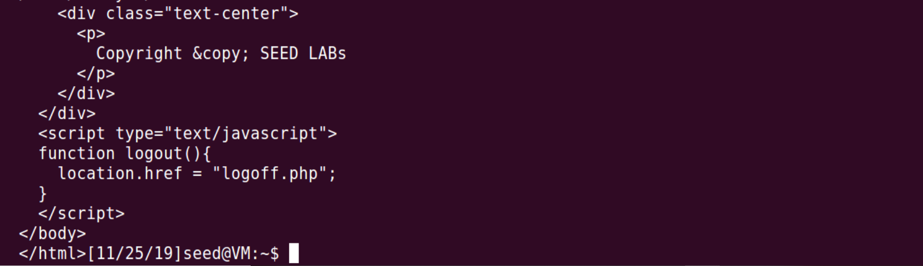

**Observation:** I have performed the same attack as before, only difference is that we perform this from the command line using the curl command and the attack is successful as shown in the above screenshots.

**Explanation:**

* To perform the attack from command line, we need to encode special characters.
* So we can get the URL from observing the HTTP Headers while performing the attack from the webpage.
* I have used the command from terminal - **curl ‘www.seedlabsqlinjection.com/unsafe_home.php?username=%27+or+Name%3D%27admin%27%3B%23&Password='**
* All the information is displayed in the command prompt as the attack is successful.

**Task 2.3:** Append a new SQL statement

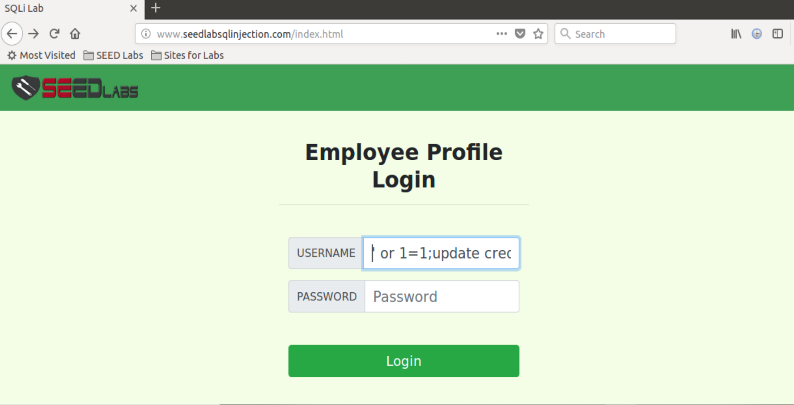

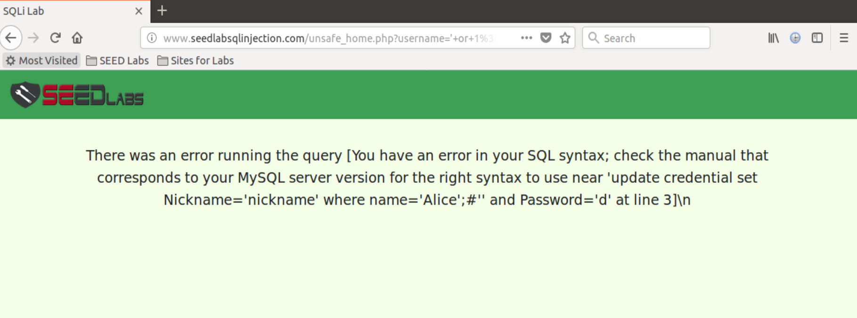

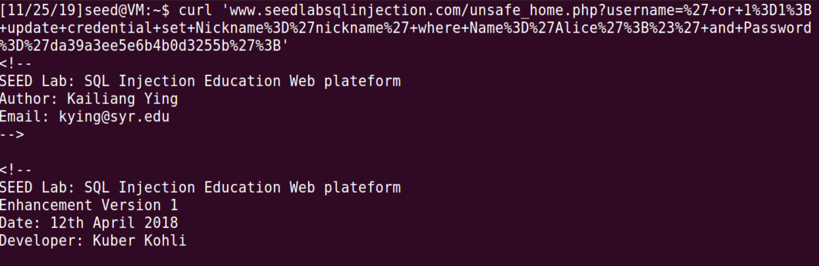 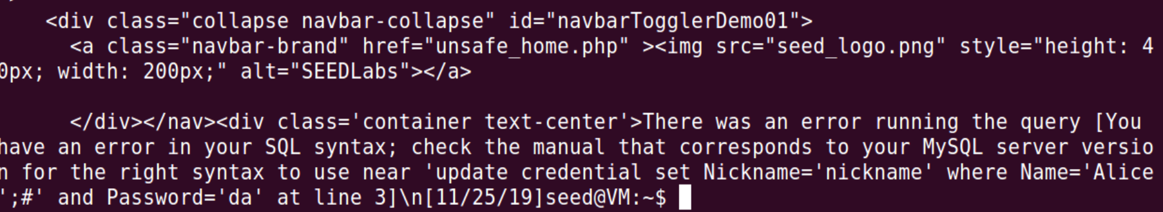

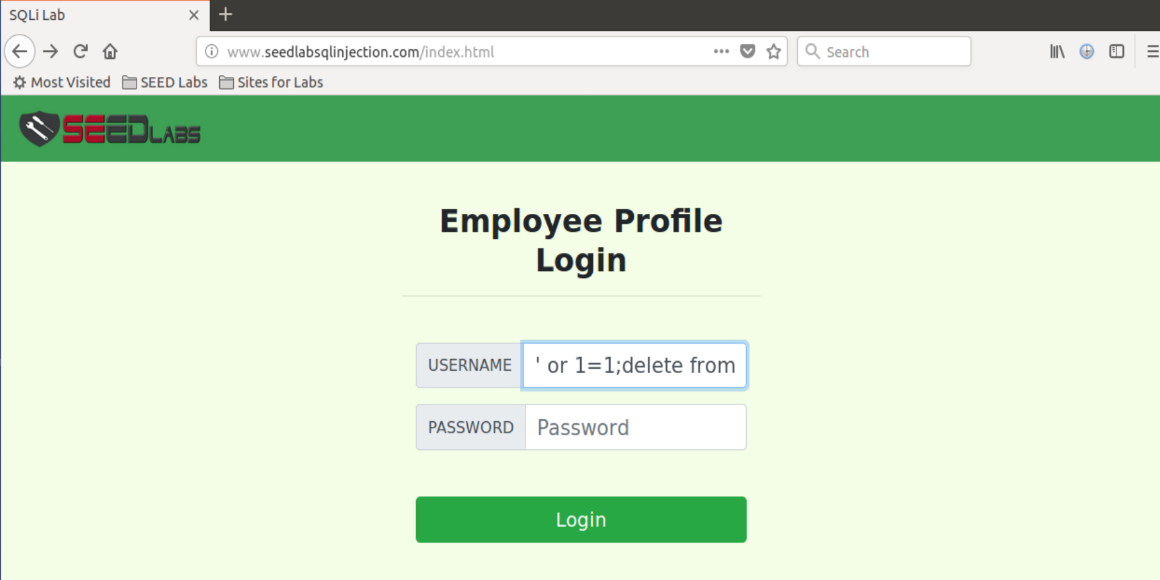

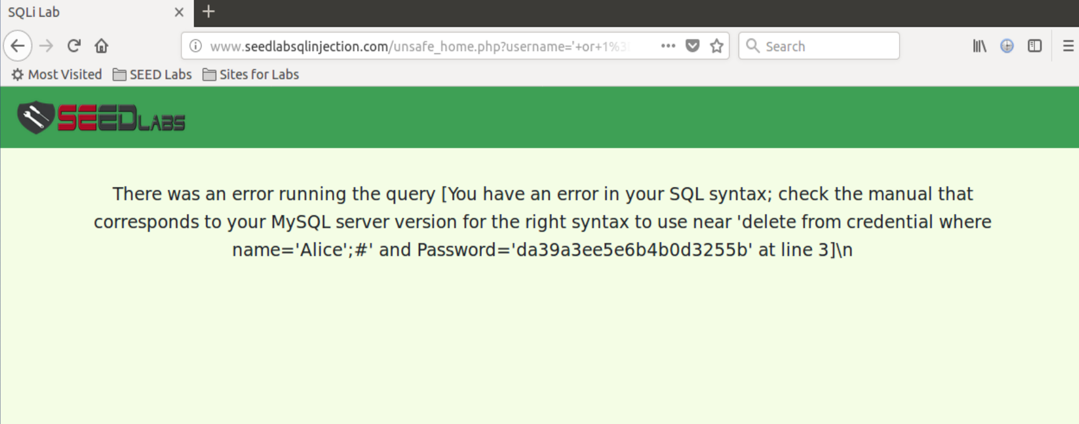

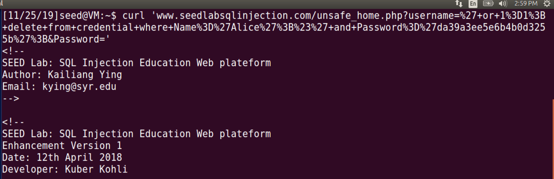 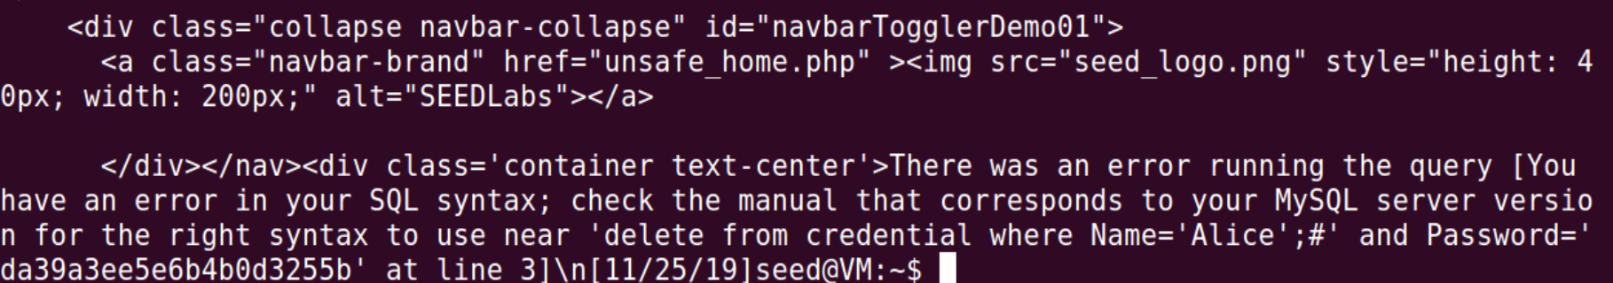

**Observation:** We append an update statement and also delete statement after the semicolon as shown in the above screenshots. The attack isn’t successful. I tried the attack from the webpage and from the command line, both attempts were not successful as shown in the above screenshots.

**Explanation:** The attack is not successful because of the countermeasure in MySQL that prevents multiple statements from executing when invoked from php.

**Task 3: SQL Injection Attack on UPDATE Statement**

**Task 3.1 :** Modify your own salary

* Login to Alice profile using **'or Name='alice';#**
* Access Alice’s profile using “Edit Profile” button
* Below is the profile information of Alice

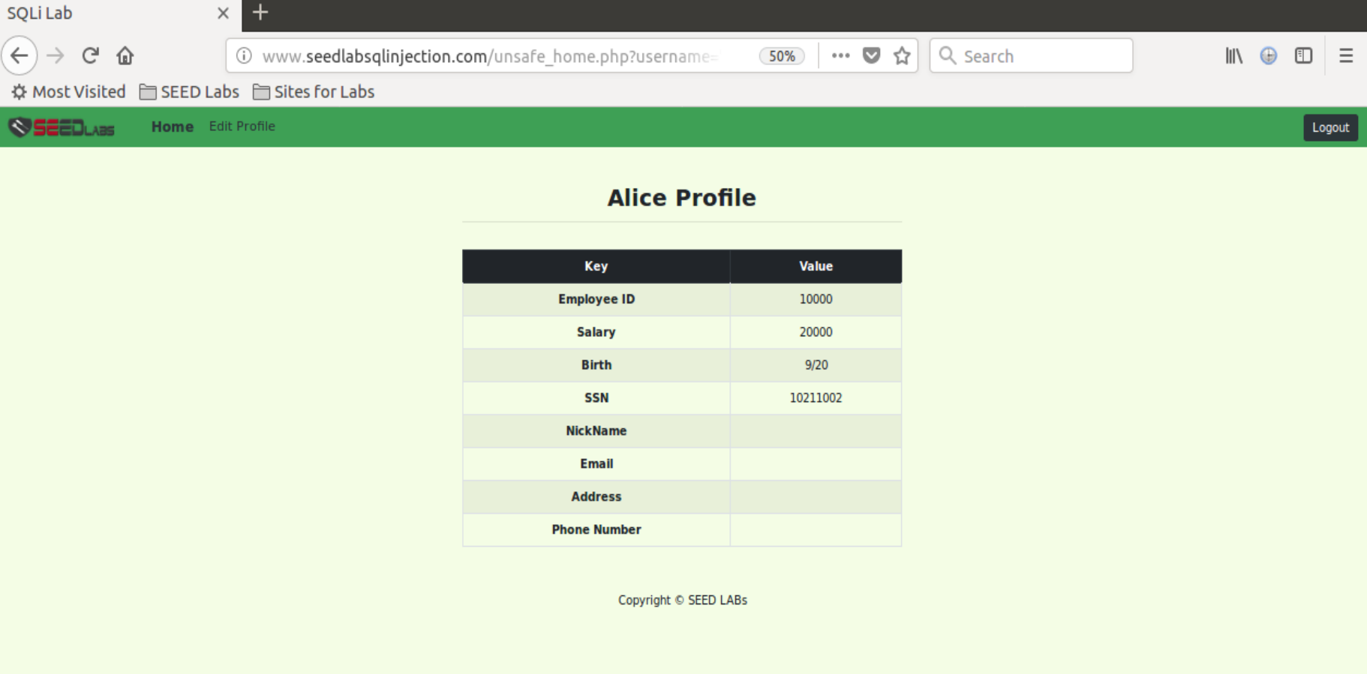

Now make the below edit to the Alice Profile Information in Nickname field - **', salary='234567' where name='alice';#**

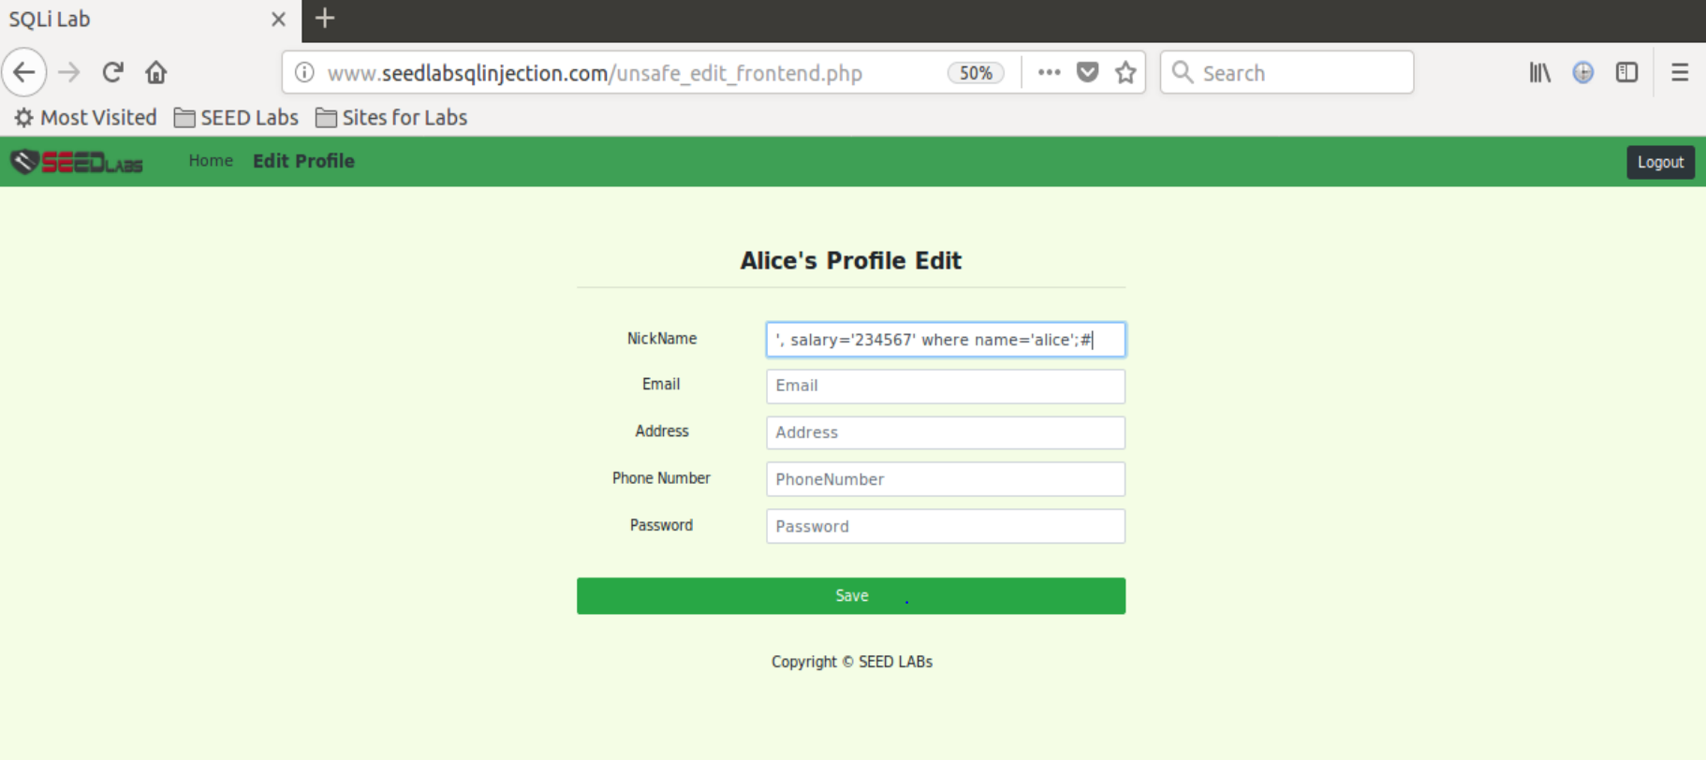

Salary is modified to **234567**

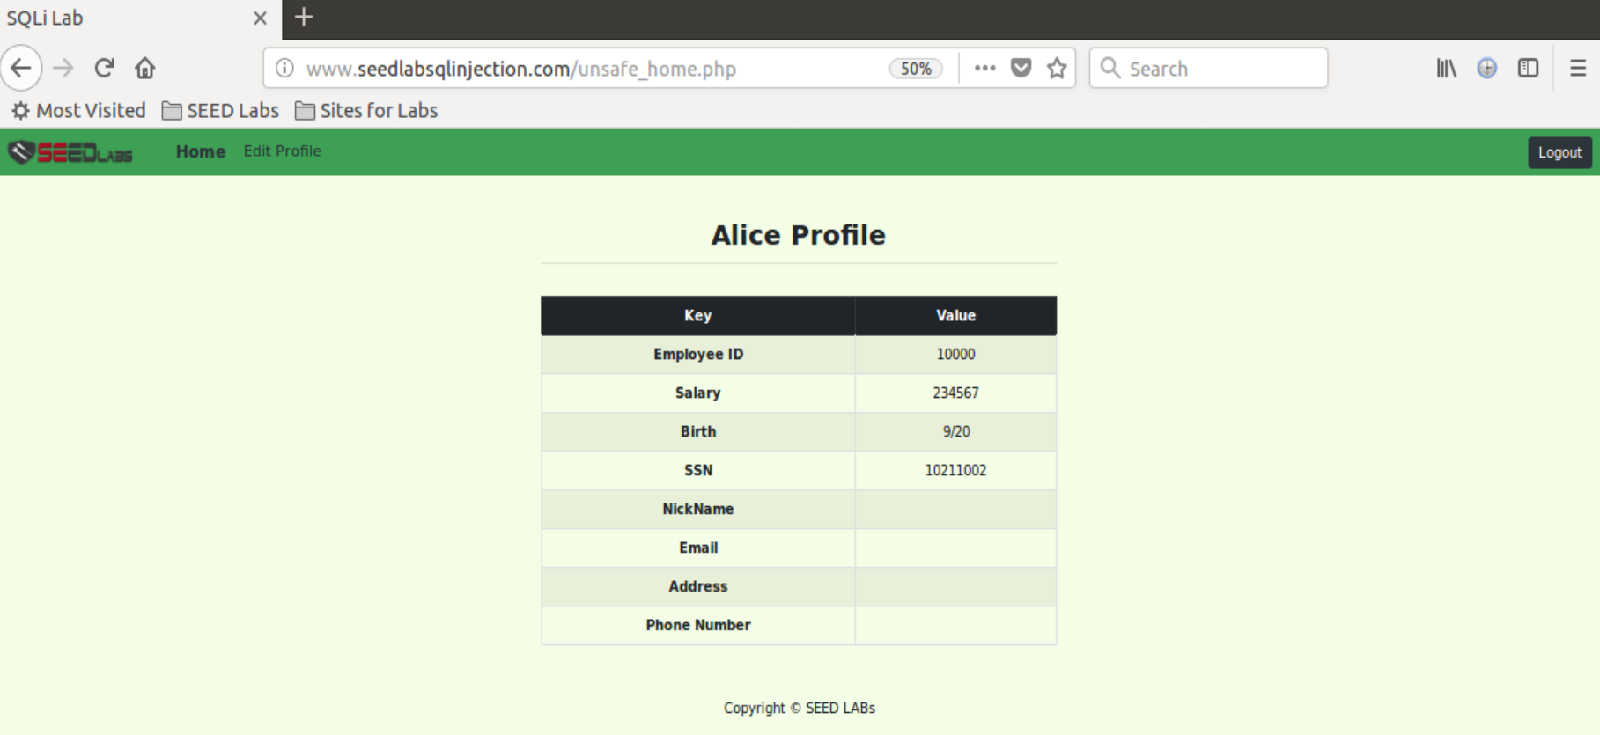

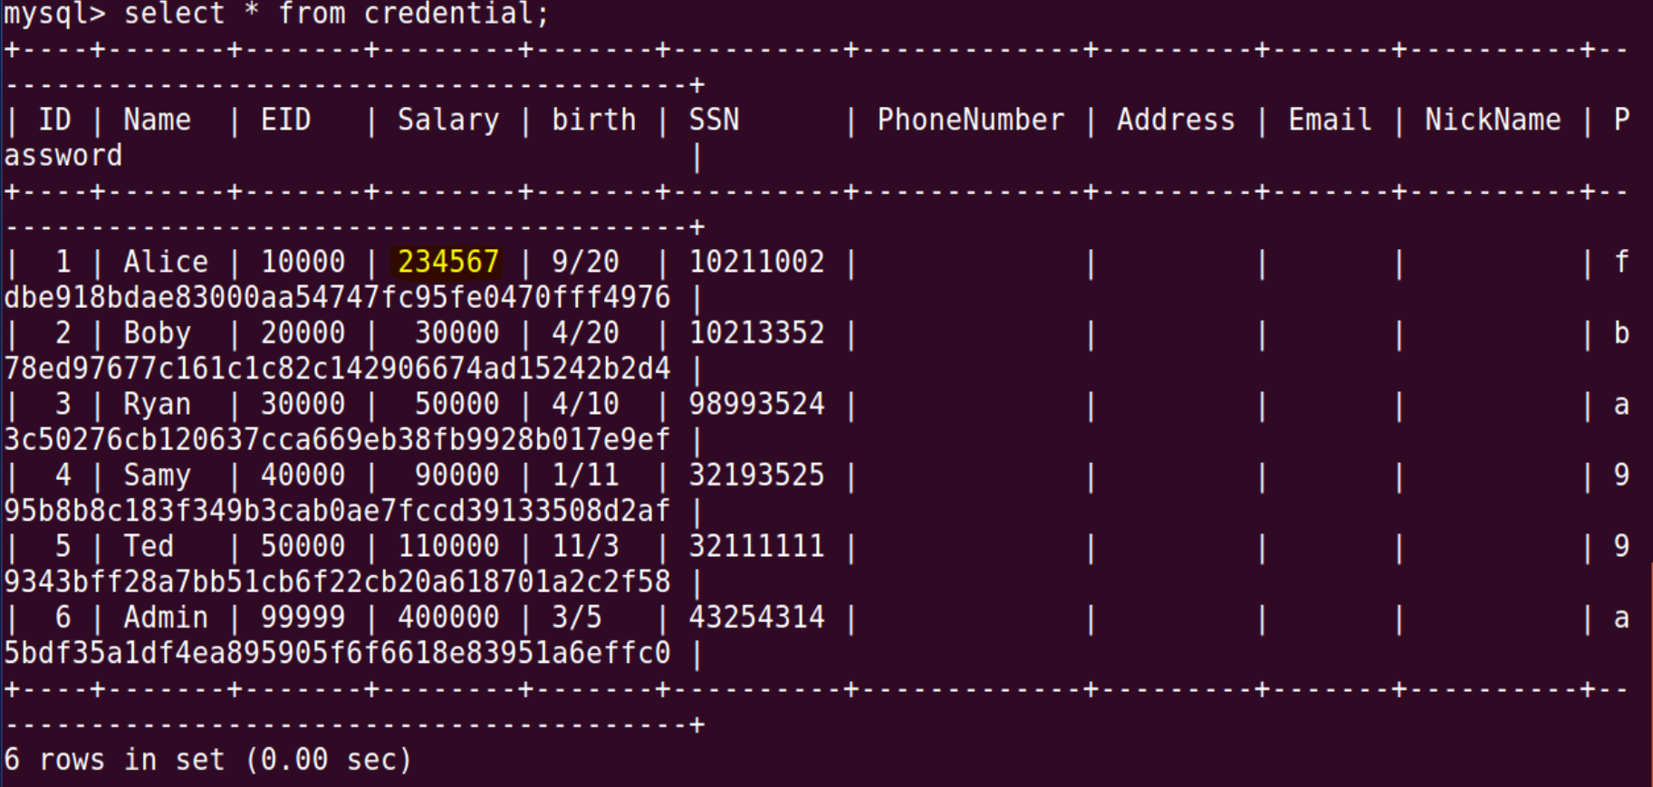

**Observation:** This screenshot shows that Alice’s salary is changed to 234567 from the previous salary.

**Explanation:** We are trying to exploit SQL injection vulnerability by inserting code in the edit profile page so that we can update the salary of the current employee. We insert a # at the end to comment out all the other values that follow so that we don’t have problems with the null or incorrect input values from other input fields. We perform this attack and update the salary field though it is not visible because it is not allowed to be edited by the employee. Only the admin can edit it. Since the attack is successful, the salary of Alice is updated.

**Task 3.2**: Modify other people’ salary

* Login to Alice profile using **'or Name='alice';#**
* Access Alice’s profile using “Edit Profile” button
* Now make the below edit to the Alice Profile Information in Nickname field - **', salary='1' where name='boby';#**

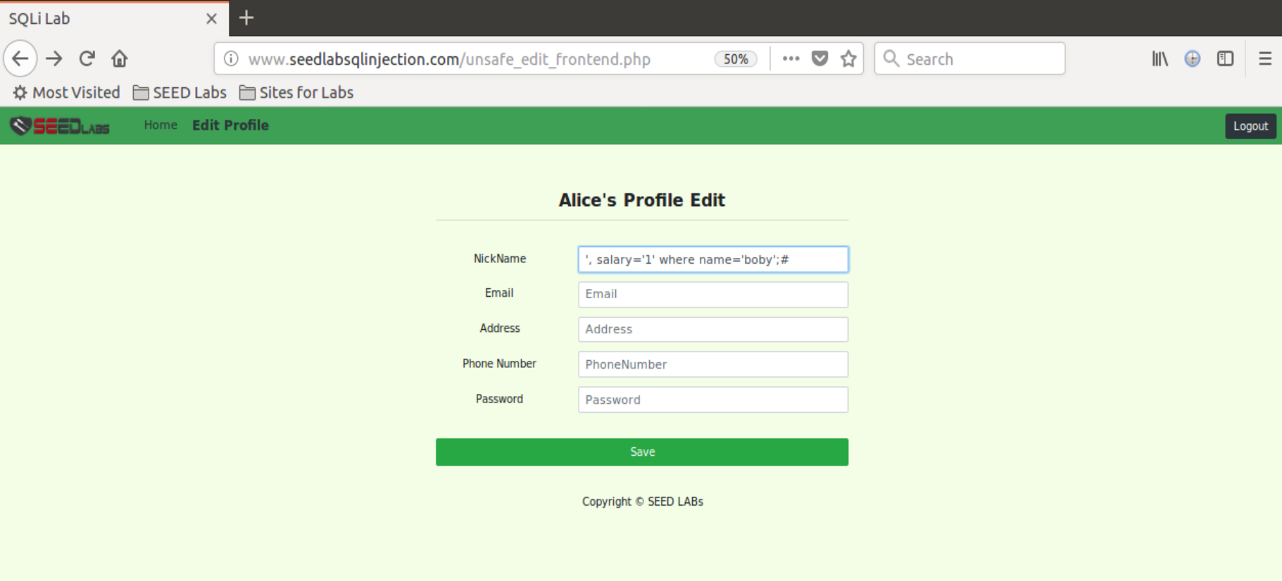

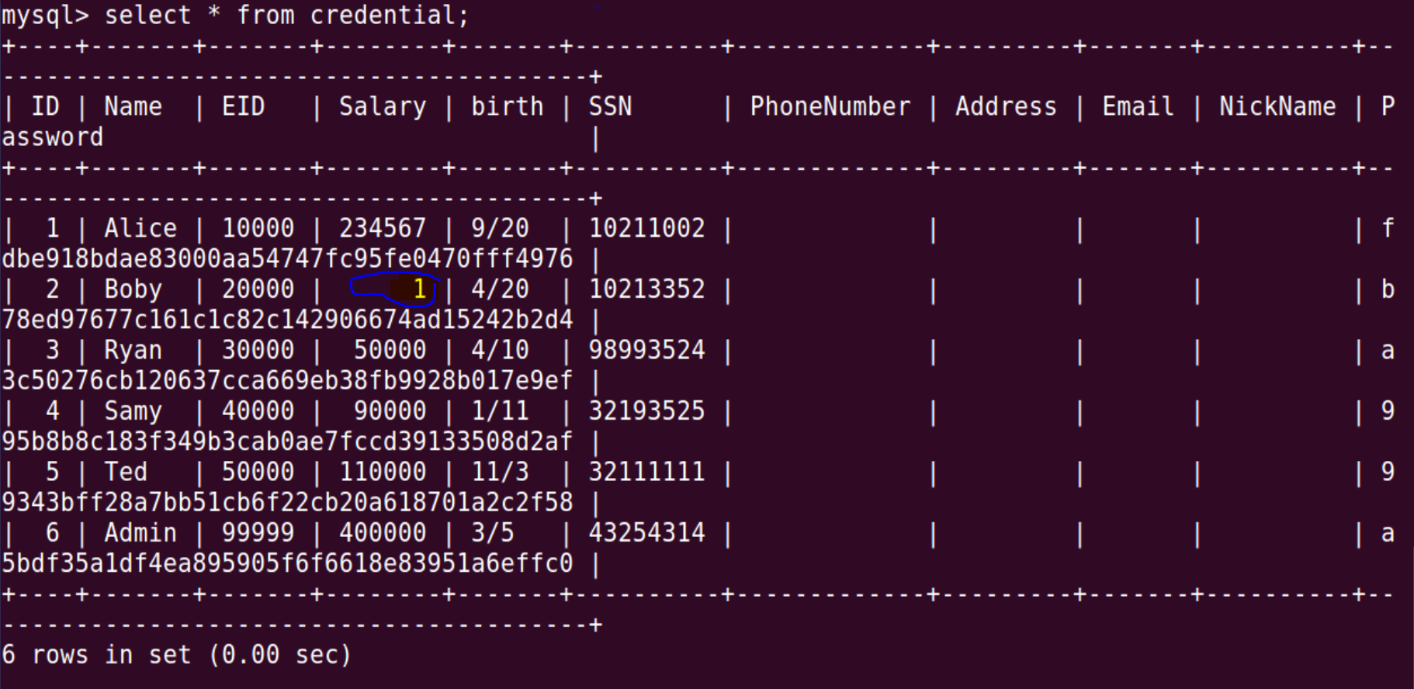

**Observation:** This screenshot shows that Boby’s salary is changed to 1 from the previous salary.

**Explanation:** We are trying to exploit SQL injection vulnerability by inserting code in the edit profile page so that we can update the salary of the current employee. We insert a # at the end to comment out all the other values that follow so that we don’t have problems with the null or incorrect input values from other input fields. We perform this attack and update the salary field though it is not visible because it is not allowed to be edited by the employee. Only the admin can edit it. Since the attack is successful, the salary of Boby is updated.

**Task 3.3:** Modify other people’ password

* Before Boby’s password Change

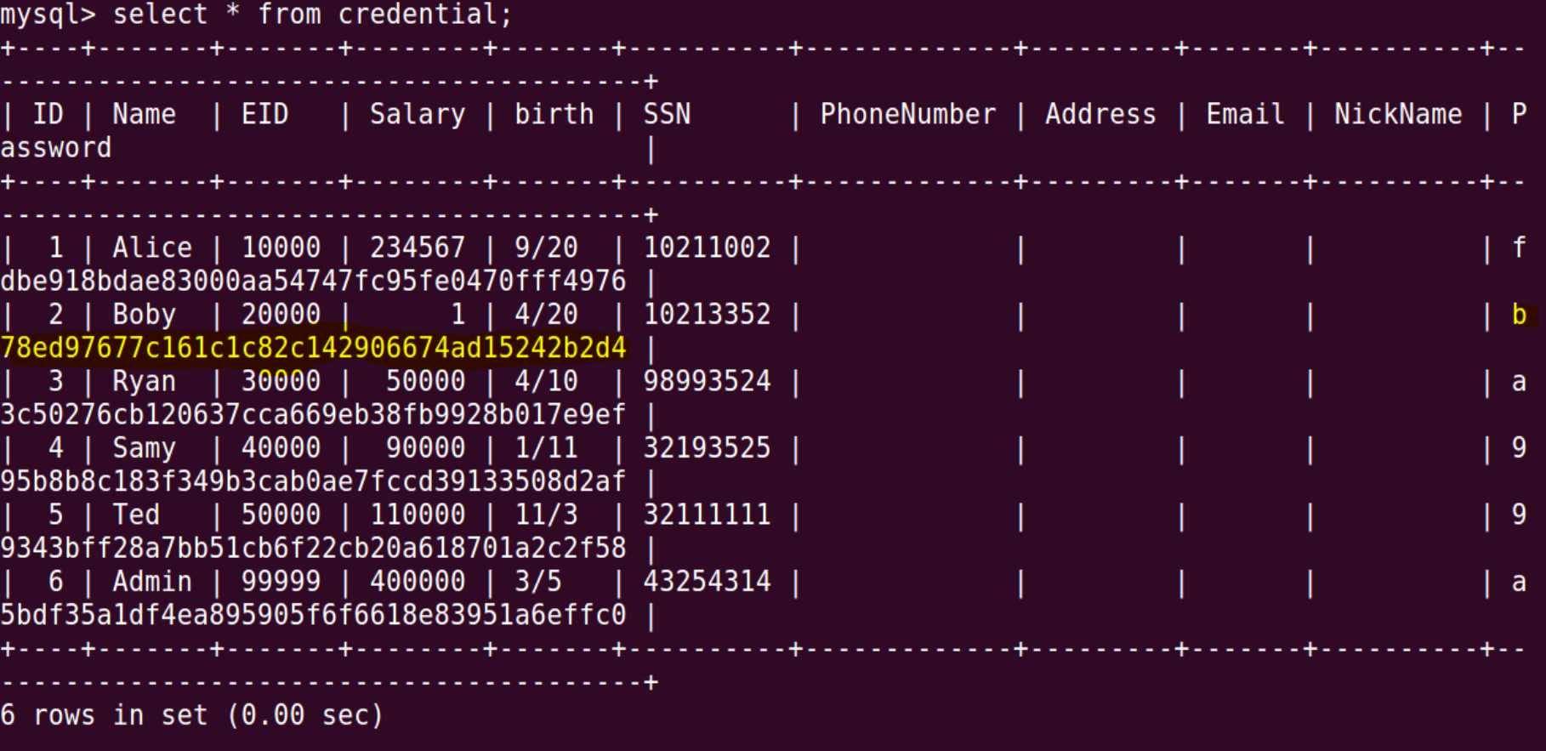

* Login to Alice profile using **'or Name='alice';#**
* Access Alice’s profile using “Edit Profile” button
* Now make the below edit to the Alice Profile Information in Nickname field –

**', Password='5087e6153fecd1aab452925cd19d95b36b109b7b' where Name='Boby';#**

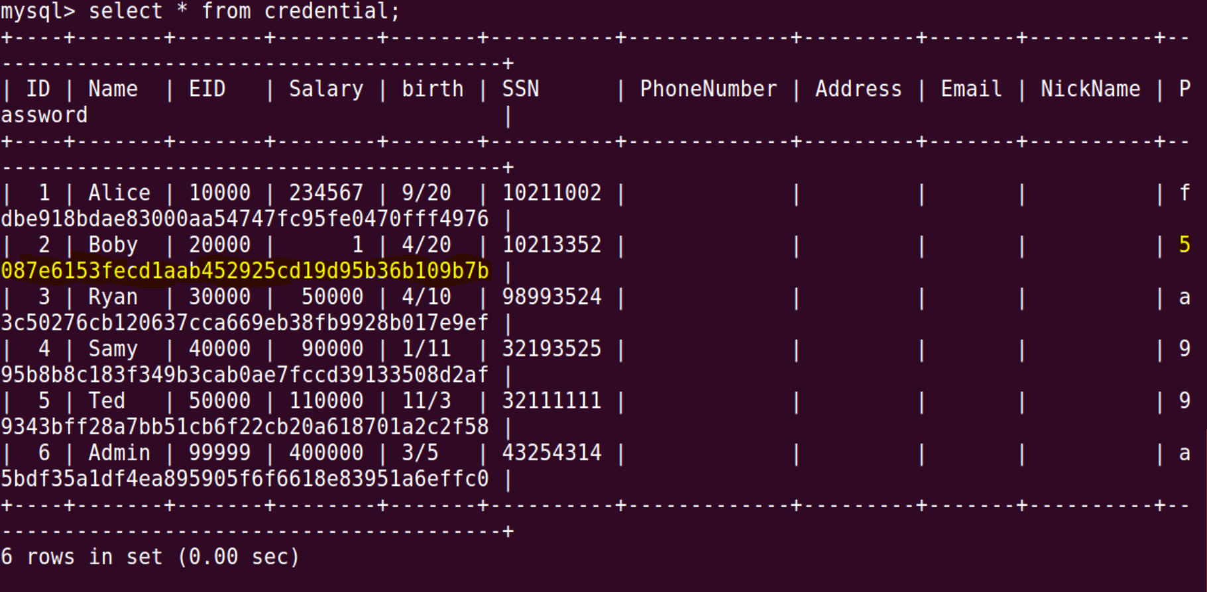

**Observation:** The below screenshot shows the way we generate the password sha1 hash, because the database stores the encoded value and not plaintext. We change Boby's password to bobyseed from seedboby.

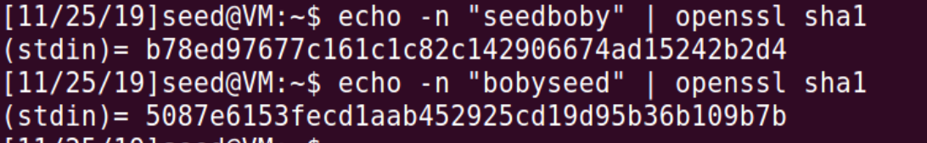

Logging into Boby Account with “bobyseed” password

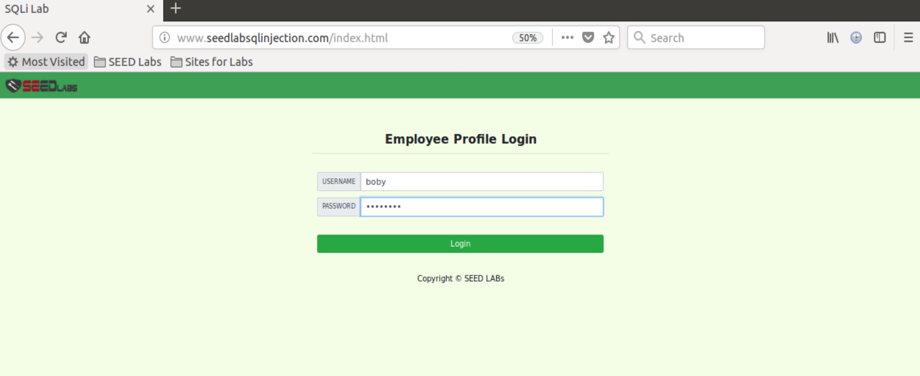

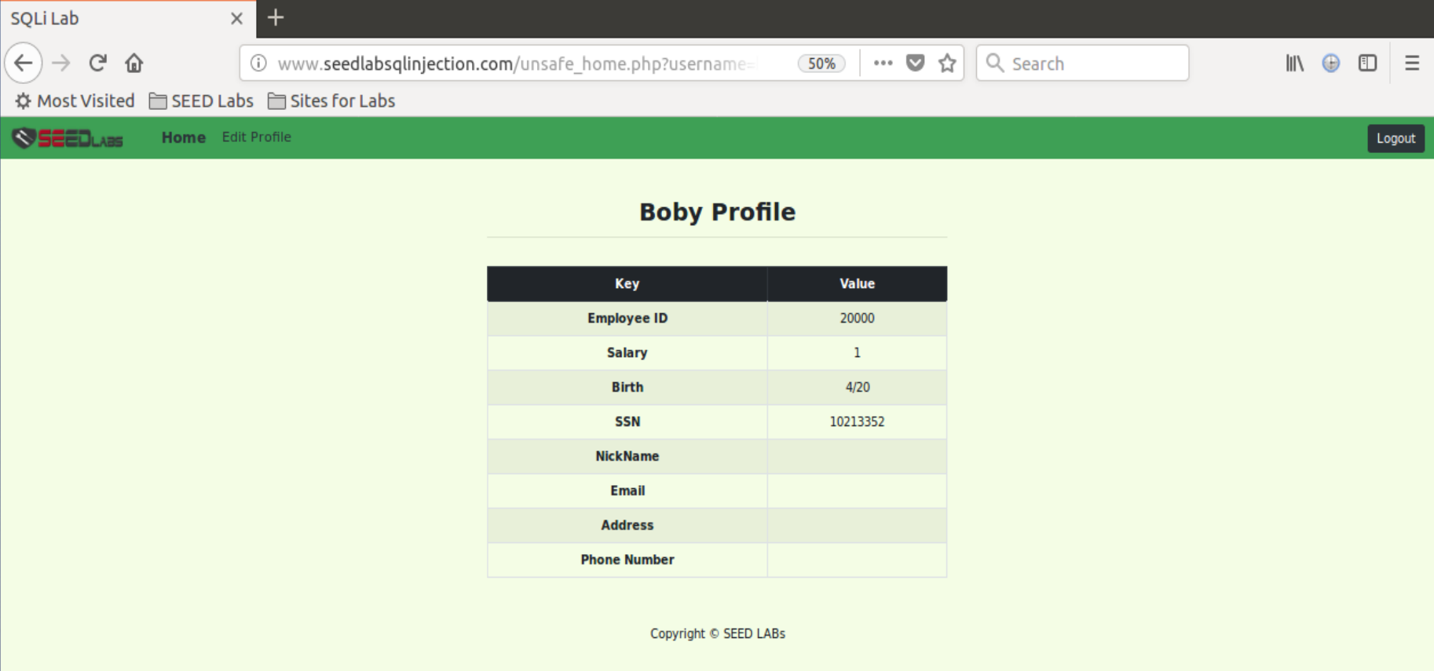

**Observation:** The above screenshots show that the attack is successful since we were able to login into Boby's account with the new password.

**Explanation:** We use the update command to change the password of some other account (Boby) from another account (Alice). This exposes the SQL Injection vulnerability. This shows how potentially dangerous it can be. We login into Alice's profile and try to edit her profile. When we enter the attack vector into the nickname field, and if the attack is successful, the password of Boby is changed. The edit profile page uses update statement to update the fields in an account, but we use the injected code to modify it and change the information of some other account. The # symbol at the end of the attack vector is used to comment out all code that follows in the original code, so that it doesn't cause problems to the attack.

**Task 4: Countermeasure — Prepared Statement**

Before Modifying the unsafe_home.php the code looks as below:

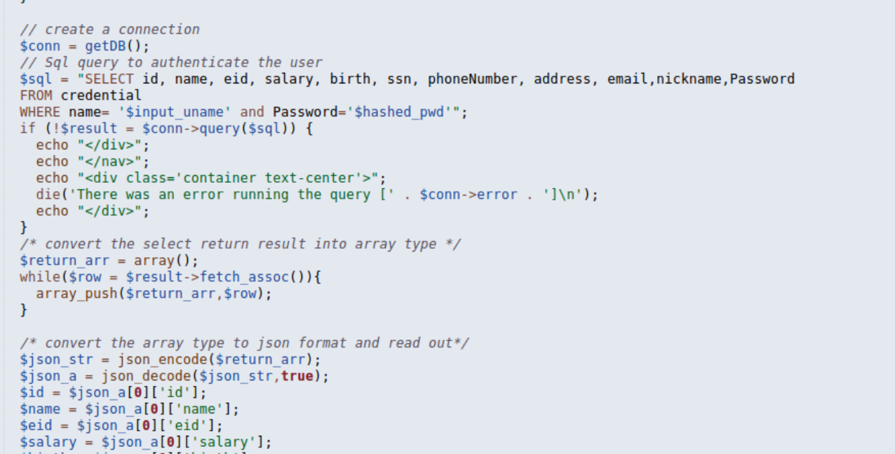

We edit the unsafe_home.php file by adding a prepared statement instead of executing a normal sql query as shown below and perform the attack as we have done previously.

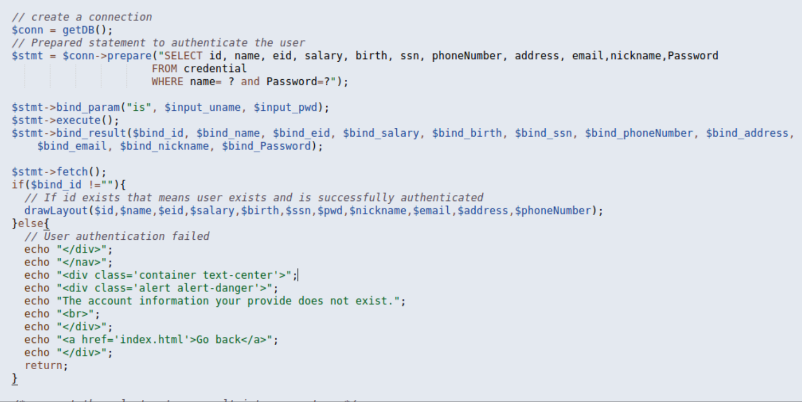

Restart the apache server

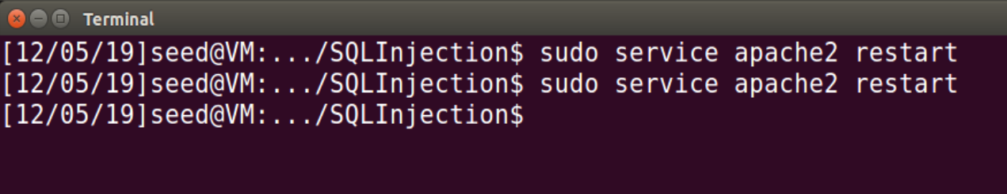

**Observation:** After this change the attack fails because of the use of prepared statement. This statement helps in separating code from data. The prepared statement first compiles the sql query without the data. The data is provided after the query is compiled and is then executed. This would treat the data as normal data without any special meaning. So even if there is SQL code in the data, it will be treated as data to the query and not as SQL code. So, any attack would fail in this protection mechanism is implemented. The output was a screen with no data and hence the session was not active.

